

Connect5 Upgrade Instructions

From 1.0 to 1.2

# 

Contents

Purpose 3

Review of Modifications 3

Changes to Libraries 3

Changes to Properties 3

Changes to Database Schema 4

Changes to Report Configuration 5

Changes to web.xml 5

# Purpose

This guide is intended to serve as an upgrade for application developers migrating to version 1.2 of the Connect5 Framework from 1.0 or 1.1. While it is always our intention to minimize the impact of product upgrades, there are inevitably areas where changes are necessary to existing implementation code and configuration in order to provide the required enhanced functionality. This guide is intended to provide a comprehensive list of those changes and serves as a checklist for the person or person(s) performing the upgrade.

***Application developers are advised to familiarize themselves with the entirety of this guide before attempting to perform an upgrade.***

## Review of Modifications

In order to successfully upgrade from 1.X to 1.2, please follow directions in the following sections.

### Changes to Libraries

Upgrade your project with the following approved jar files.

1. Base libraries that will overwrite some of your existing libraries:

|  |  |
| --- | --- |
| apmodule.jar | lib |
| applatform.jar | lib |
| apsubstrate.jar | lib |
| apupload.jar | lib |
| eip.jar | lib |

If your existing application hijacked any of the framework classes, you will need to reconcile those differences and determine if the functional changes are implemented as expected in the new versions. *Continuing to use Java source files hijacked in an older version will most likely yield exceptions being raised - the best of scenarios - and unexpected results at runtime - the worst of scenarios.*

1. 3rd Party Libraries that will overwrite some of your existing libraries:

|  |  |
| --- | --- |
| commons-el-1.0.jar | lib |
| groovy-all-2.1.2.jar | lib |
| snakeyaml-1.11.jar | lib |

### Changes to Properties

Properties are now grouped into 6 files they are:

* **framework.properties**
* **pilotfish.properties**
* **logging.properties**
* **interface.properties**
* **message.properties**
* **upload.properties**

This section enumerates the pilotfish properties that were changed.

|  |  |  |
| --- | --- | --- |
| **pilotfish property** | **default** | **Notes** |
| com.pilotfish.eip.enableStageReporting | false | When set to true, stage processing time is recorded to database. |
| com.pilotfish.eip.enableTransactionReporting | true | When set to true, key transaction information is recorded to the database. |
| com.pilotfish.eip.enableParamReporting | true | When set to true, configured report parameters are recorded to the database. |
| com.pilotfish.eip.enableMessageLogging | true | When set to true, message data is written to the file system before and after exiting a route. |
| com.pilotfish.eip.messageLoggingDirectory | ${output_dir}/messages | The location where message data will be logged. |
| com.pilotfish.eip.enableAttributeLogging | true | When set to true, message attributes are written to the file system before and after exiting a route. |
| com.pilotfish.eip.attributeLoggingDirectory | ${output_dir}/attributes | The location where message attributes will be logged. |
| com.pilotfish.eip.enableStageLogging | false | When set to true, stage data is written to the file system before and after exiting a route. |
| com.pilotfish.eip.stageLoggingDirectory | ${output_dir}/stages | The location where stage data will be logged. |

### Changes to Database Schema

An update SQL script(s) for your specific database type has been supplied which can be used to create the new *PF_EIP_PARAMLOG* table. It also supports the alteration of the *PF_EIP_TRANSACTIONLOG, PF_EIP_TRANSPORTLOG, PF_EIP_ERRORLOG and PF_EIP_PARAMLOG* tables.

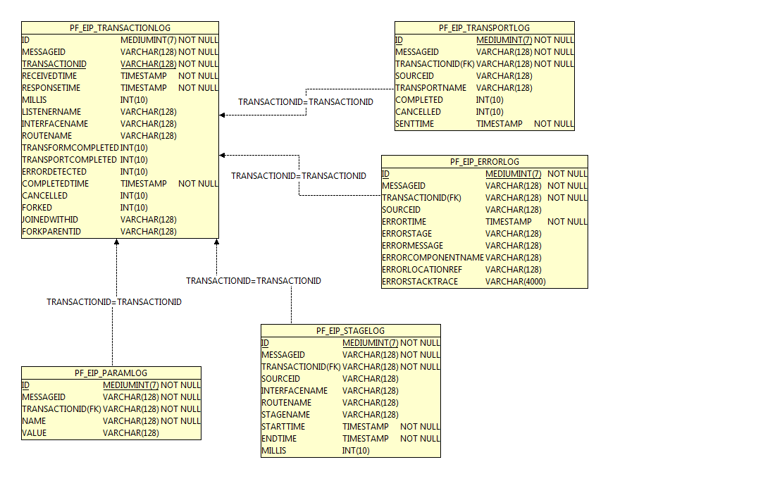

### Changes to Report Configuration

Release 1.2 introduced a new configuration file to store Report Parameters. These parameters are stored in the *PF_EIP_PARAMLOG* table that has indexes on both TRANSACTIONID and NAME columns. See the **report_param.xml** file included in the build.

### Changes to web.xml

A couple of changes were introduced to the **web.xml** file. One change is the ability to declaratively configure exclusions on the ACSI security filter. This allows one to configure the ACSI security filter in an “all but these end points" way.

The following web.xml entries should be added:

The servlet entry listed below needs to be added in the same section with other servlet entries.

<servlet>

<servlet-name>AdminServlet</servlet-name>

<display-name>Admin Servlet</display-name>

<description>Servlet to handle presentation of Connect5 administration pages.</description>

<servlet-class>com.agencyport.substrate.platform.APAdminServlet</servlet-class>

</servlet>

The servlet-mapping entry needs to be added to the same section with other servlet-mapping entries.

<servlet-mapping>

<servlet-name>AdminServlet</servlet-name>

<url-pattern>/admin/*</url-pattern>

</servlet-mapping>

The welcome-file entry needs to be updated in the session-config element.

<welcome-file>index.jsp</welcome-file>